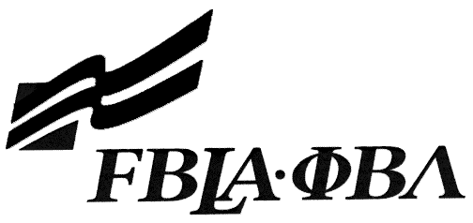 FBLA Statement of Assurance

Arizona Event Entry Form
This form must be completed and attached to your online event submission. For state competition, go to the SLC event submission page to access the online submission form for your event.

Check one: 3D Animation E-business
Coding & Programming Mobile Application Development
Computer Game & Simulation Programming Website Design
Digital Video Production Digital Photography: Commercial Photography
Digital Photography: Professional Business

Provide the complete URL for E-business, Digital Video Production, and Website Design. These events will be judged online. Make sure the URL link is valid through the National Leadership Conference.

State: |  |  | Check One: FBLA
School:
Website URL Address: (where appropriate)
Member(s) Name:
Local Chapter Contact
Name:
Daytime/Cell Number:
Home E-mail:

I/We, the undersigned, attest that the design, creation, and implementation of the event are the original work of the above chapter member(s). I/we agree that this event may be linked, promoted, and used in any way by the national FBLA-PBL, Inc. for purposes of promoting the association. (Typed name is accepted for signature)
Name of Team Member |  | Adviser’s Name
Name of Team Member |  | Name of Team Member
Complete this Document Section for the Above Events:
Software Used:
Source of Information:
Copyright Notations
Instructions for Running Project:
Template(s) Used (source)

